Project Proposal for Dealership CMS

Prepared by Shawn Ibragimov

WEBDEV-2013

20.07.2024

**1. Project Overview:** The Dealership CMS (Content Management System) is a web-based application designed for managing vehicle inventory and sales processes for a car dealership. The CMS will allow users to create and work with car listings through a user-friendly interface.

**2. Objectives:**

* Develop a web application to create and manage car listings.
* Provide an intuitive user interface for dealership staff to perform CRUD (Create, Read, Update, Delete) operations.

**3. Features:**

* **Main Page:** All listings will be displayed on this page.
* **Listing Creation and Changing:** Add, edit, view, and delete vehicle listings, including details like image, make, model, year and price.
* **Search & Filter:** Search and filter vehicles and customers based on various criteria.
* **User Roles:** Different access levels for dealership staff (full control) and users (limited access).

**4. Technical Specifications:**

* **Front-end:** HTML, CSS, JavaScript
* **Back-end:** PHP, working with DB using PDO
* **Database:** MySQL
* **Authentication:** Basic authentication with role-based access control using cookies and sessions.
* **Deployment:** Local server for development; Cloud hosting for demonstration

**5. Deliverables:**

* Fully functional web application with the features listed.
* Source code repository with version control.

**6. Timeline:**

* **Week 1:** Project planning, requirement gathering, and initial design.
* **Week 2:** Set up development environment, create database schema, and develop basic CRUD functionalities.
* **Week 3:** Implement advanced features (search, filter, roles) and refine UI/UX.
* **Week 4:** Testing, debugging, and final adjustments.
* **Week 5:** Project presentation.

**7. Evaluation Criteria:**

* Functionality: All features are working as specified.
* Usability: User interface is intuitive and user-friendly.
* Code Quality: Code is well-organized and understandable.

**8. Resources Needed:**

* Development tools (VSCode, GIT)
* Hosting (VPS)
* 10 car listings information

**9. Database overview**:

Cars table:

* id: int – autoincrement PK
* make: str
* model: str
* price: int
* description: str
* type: id
* img_path: str – path to image

Comments table:

* listing_id: int FK
* user: str
* comment: str
* date: dateType

Types table:

* id: int – autoincrement unique
* type: str

**10. ERD:**

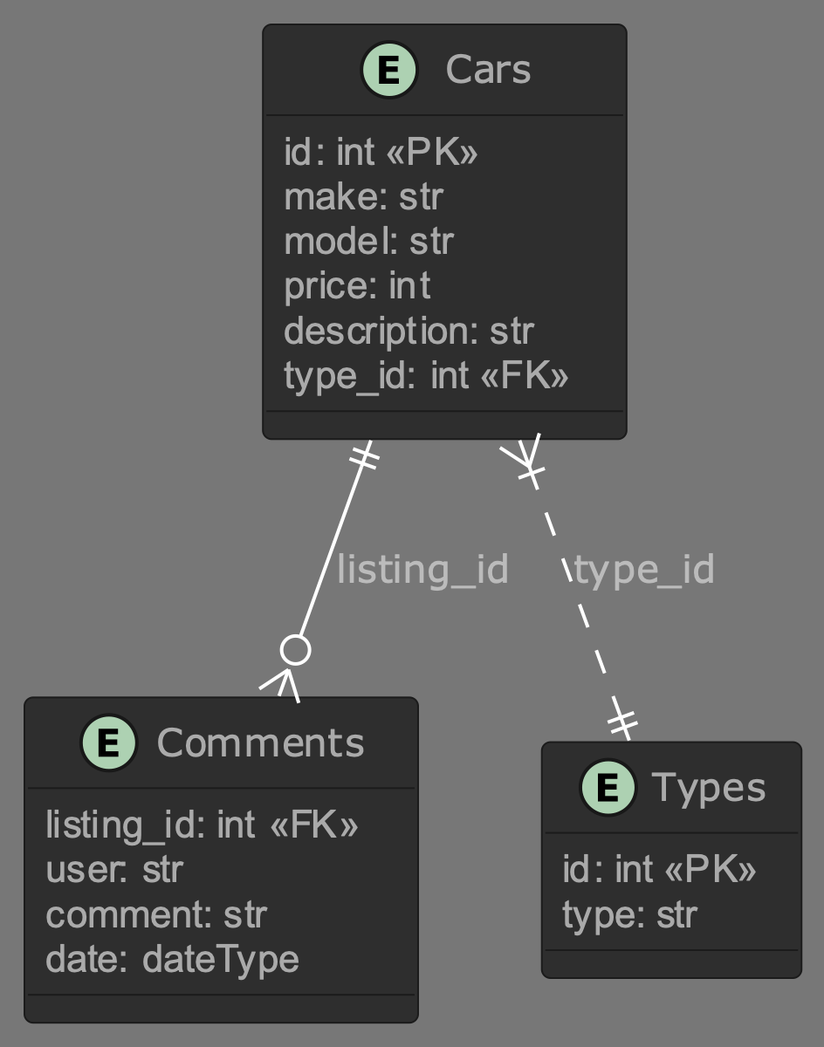

11. GitHub Repository: https://github.com/shah-ibrag/dealership-cms